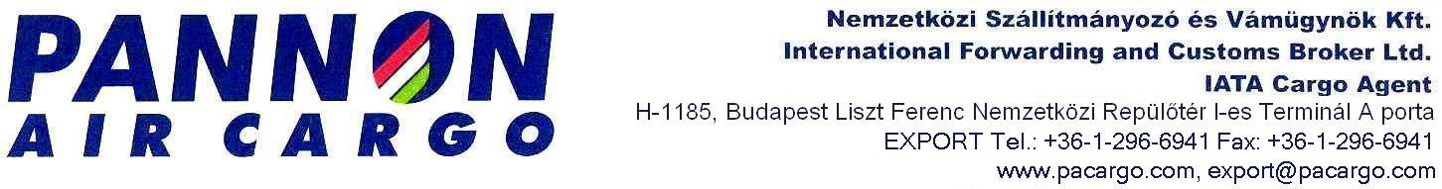

ASSIGMENT -VPID FOR ECONOMIC ORGANISATIONS

Undersigned ,
( Name)……………………………………………………………………………………….
as authorized representative of
(Company name:)………………………………………………………………………………
(Seat:)………………………………………………………………………………….
hereby authorize Pannon Air Cargo Ltd. (seat:1185 Budapest Liszt Ferenc International Airport) to act on behalf of the said company with full power and to apply for the so called „VPID number” at National Tax and Customs Administration of Hungary (NTCA)
Date : ……………201.

………………………….. ……………………..
(Name ) (Name)
Client Proxy
Pannon Air Cargo Ltd.

Witness 1 : Witness 2
Name: ……………………………. Name: …………………………..
Address…………………………… Address: …………………………
ID.Nr.: ……………………………. ID.Nr.: …………………………..

